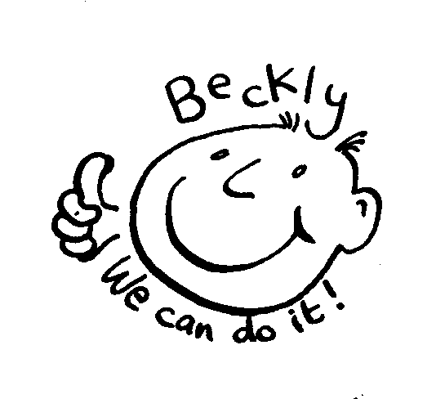
Beckly Adult Social Group
Monday evenings 7pm to 9pm

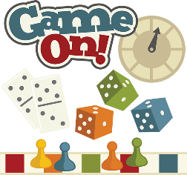

Monday 31st July Social and Games evening
What’s your favourite game come along, play and share your skills

Monday 13th August Evening Stroll at Mount Batten Meet at Jennycliffe Car Park at 7pm for a stroll along the coast foot path
down to Mount Batten and a quick coffee or drink in the pub before walking
back up to Jennycliffe for collecting at 9pm
Wear good walking shoes some steps.
Hopefully we can spot some butterflies for the National Survey

Monday 27th August Bank Holiday Closed

Monday 10th September Pizza evening at Beckly
Check out the Beckly Larder for some healthy ingredients to create, cook and share some pizza

Charge for sessions is £5.00 per evening
Please let us know if any of your details have changed so we can update our records

We need more people to regularly join in our activities so encourage your friends and colleagues to come along to the group... the more people the merrier and the more activities we will be able to do If you can put copies of this timetable up on notice boards or hand out at college, in day centres, to social groups or at work then let us know

Contact us if you have any queries or need more details
Ring on 484433 or email: beckly@routeways.org.uk
keep up to date www.facebook.com/becklycentre

