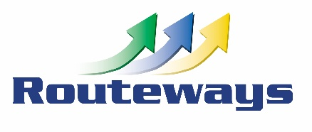
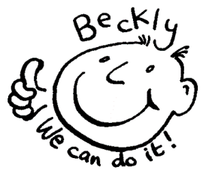
Beckly Centre,
Mayers Way Plymouth PL9 9DF
01752 484433 or 07780662391
www.facebook.com/BecklyCentre |  | Email beckly@routeways.org.uk
July Weekend Session
Session times 10:30 – 15:30

Sat 7th July All things USA
It’s Independence Day so will be creating the perfect hotdog
Sat 14th July Plymouth Respect Festival
It’s Respect festival this week so we will exploring different cultures
Sat 21st July Here comes the Summer
Getting ready for summer, sun and beach safety

Sat 28th July Summer BBQ
Creating, cooking an sharing a “healthy” BBQ

Payment Details: Cheques should be made payable to Routeways Centre Ltd.
Bank Transfer/Internet Banking: Please put your surname and Beckly in the reference so that we can identify the payment.
Name: Routeways Centre Limited | Account no: 40800741 |  | Sort Code: 56-00-63
Cancellation Policy: Sessions booked will be charged for and all sessions should be paid for in advance.
Where cancellation notice is received more than 5 working days in advance of the booked date then a charge of 25% of session fee will be due, where cancellation is within 5 working days then charge of 100% of session fee will be due
complete this section & return to Beckly OR email us direct with the bookings beckly@routeways.org.uk
summer playscheme dates will be confirmed and programme themes and details sent on
Name of Young Person
Contact Email/Phone
July weekend Sessions
Saturday 7th July |  |  | Saturday 14th July |  | Saturday 21st July
Adv Booking for Summer |  |  | Holiday playscheme sessions |  | Circle dates required
Mondays |  |  | Wednesdays |  | Fridays
July 23rd 30th |  |  | July 25th |  | July 27th
Aug 6th 13th 20th 28th |  |  | Aug 1st^{th} 8th 15th 22nd 29th |  | Aug 3rd 10th 17th 24th 31st
Sept 3rd
Weekend Sessions |  |  | Saturdays
July 28th |  |  | Aug 4th 11th 18th 25th |  | Sept 1st 8th
Charge for each session is £32.50 payable in advance for direct personal bookings
For bookings as part of Care Plans, by Local Authorities and other Agencies please contact us

